Unveiling The Virtual Classroom: An In-Depth Analysis of The Online Education System using IBM Cognos

SASIKALA M
Assistant Professor,
Department of Information Technology,
Sona College of Technology, Salem, Tamil Nadu, India.

1 INTRODUCTION

  - Overview

In a world transformed by the unprecedented challenges of the lockdown period, the emergence of online classes and technology has played a superheroic role in ensuring continuity in education. Even as physical movement was restricted, the realm of online education provided a lifeline, connecting students to the world of learning. This project delves into the profound impact of online education during the lockdown, uncovering its strengths, weaknesses, opportunities, and challenges.

  - Background

The lockdown compelled individuals across the globe to remain within their homes, effectively isolating them from external interactions. Particularly, students faced a lack of exposure due to the restrictions on physical movement. Recognizing the need for uninterrupted learning and mental well-being, the education sector swiftly transitioned to online classes. This transformation was a testament to the resilience of educators and their commitment to ensuring that learning remains unhindered.

  - Objectives
The primary aim of this project is to conduct an in-depth exploration of online education during the lockdown period. By analysing its multifaceted aspects, the project seeks to achieve the following objectives:
- Examine the strengths and advantages of online education, such as flexibility, accessibility, and personalized learning experiences.

- Evaluate the weaknesses and challenges associated with online education, including issues of connectivity, digital divide, and potential loss of traditional classroom interactions.

- Identify opportunities for further innovation and improvement in online learning methodologies, content delivery, and engagement strategies.

- Address the socio-economic impact of online education, particularly its role in bridging educational disparities and enabling learning in marginalized communities.

- Provide insights to educational institutions, policymakers, and online learning platforms for optimizing the effectiveness and accessibility of online education.

2 LITERATURE SURVEY

2.1 Existing problem

There are different analysis are done by various researchers all over the world in the field of online education.

"Evidence-Based Practices in Online Learning: A Meta-Analysis and Review of Online Learning Studies" by U.S. Department of Education (2010). This report provides a comprehensive overview of the research on online learning. The findings suggest that online learning can be effective, but there is still a need for more research to identify the factors that contribute to its success.

"A Systematic Review of Research on Online Teaching and Learning from 2009 to 2018" by Tallent-Runnels et al. (2020) reviews research on online teaching and learning from 2009 to 2018. The study found that online learning is effective for learning, but there are some factors that can affect its effectiveness, such as the quality of the instruction and the student's motivation.

"Online Learning: A Panacea in the Time of COVID-19 Crisis" by Shivangi Dhawan (2020). This paper discusses the role of online learning in the time of the COVID-19 crisis. The author argues that online learning can be a valuable tool for providing education to students who are unable to attend school in person. However, the author also cautions that online learning is not a perfect solution and that there are challenges that need to be addressed.

"Faculty's and Students' Perceptions of Online Learning During COVID-19" by Li and Lalani (2021) examines the perceptions of faculty and students on online learning during the COVID-19 pandemic. The study found that both faculty and students had mixed views on online learning, but overall they were positive about the experience.

"Students' Perceptions towards the Quality of Online Education: A Qualitative Approach" by Yang and Cornelius (2021) uses a qualitative approach to investigate the perceptions of students on the quality of online education. The study found that students had a variety of opinions on the quality of online education, but overall they were positive about the experience.

"The Impact of Online Learning on Student Outcomes: A Meta-Analysis of 50 Studies" by Means et al. (2022) conducts a meta-analysis of 50 studies on the impact of online learning on student outcomes. The study found that online learning is effective for learning, but there is some variation in the effects depending on the study design and the student population.

"The Role of Social Presence in Online Learning" by Tu et al. (2022) examines the role of social presence in online learning. The study found that social presence is an important factor in student engagement and learning in online courses.
2.2 Proposed solution
In an era defined by technological acceleration, our approach to education has undergone a profound transformation. The traditional classroom, once synonymous with learning, has been reimagined in the virtual realm. As the world evolves, so too must our educational paradigms. It is within this context that we present "Unveiling The Virtual Classroom: An In-Depth Analysis of The Online Education System."
The landscape of education is undergoing a seismic shift, propelled by the convergence of digital innovation and global connectivity. As we journey through this comprehensive analysis, we will uncover the multifaceted dimensions of online education, dissecting its strengths, grappling with its challenges, envisioning its potential, and acknowledging its socio-economic impact.

2.2.1 Strengths and Advantages of Online Education:
To highlight the strengths and advantages of online education, we propose an immersive approach that combines compelling narratives with data-driven analysis. Engaging case studies will showcase the stories of students who have benefited from flexible learning schedules, allowing them to balance education with other commitments. Interactive multimedia elements, such as video interviews and testimonials, will bring these stories to life. Additionally, infographics and visualizations will be used to present statistics on the growth of online education and its positive impact on student performance and career outcomes. This will help readers easily grasp the quantitative benefits of online education, adding depth to the narrative.

2.2.2 Weaknesses and Challenges of Online Education:
To address the challenges of online education, we will adopt a human-centered approach. Personal anecdotes from educators and students will illustrate the struggles of maintaining motivation and engagement in virtual classrooms. Video interviews with experts will delve into the psychological aspects of remote learning and the potential feelings of isolation.The use of relatable scenarios in scenarios in the form of short stories or dialogues will allow readers to empathize with the challenges faced by learners in online environments. To reinforce these challenges, graphical representations of surveys and studies will underline the disparities in internet access and its impact on equitable education.

2.2.3 Opportunities for Innovation and Improvement:
In this section, we will provide a futuristic vision of online education, integrating advanced technologies to engage readers' imaginations. Virtual reality walkthroughs of innovative online classrooms will give readers a glimpse of what the future could hold. Demonstrations of AI-driven personalized learning experiences will showcase the potential for adapting content to individual learning styles.
Interactive elements such as quizzes or simulations will allow readers to experience firsthand the benefits of gamified learning and adaptive algorithms. These engaging elements will encourage readers to reflect on the possibilities for transforming the learning experience.

2.2.4 Socio-Economic Impact of Online Education:
To address the socio-economic impact, we propose a multimedia-rich approach that combines text with impactful visuals. Photo essays showcasing students from remote areas accessing education online will humanize the disparities that online education can bridge. Video documentaries will follow the journey of educators bringing education to underserved communities through digital platforms. Data visualizations will illustrate the positive correlation between online education and increased employability, emphasizing how it contributes to breaking the cycle of poverty.

3 THEORITICAL ANALYSIS

3.1 Block diagram

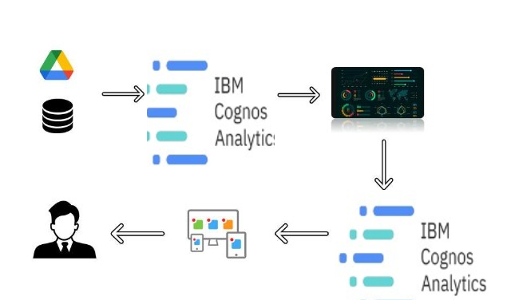

3.2 Hardware / Software designing.

- IBM Cloud
- IBM Cognos

4 . EXPERIMENTAL INVESTIGATIONS

To comprehensively analyze the dynamics of the online education system, our research methodology integrates both quantitative and qualitative experimental investigations. Through this approach, we aim to provide a well-rounded understanding of the various facets of virtual classrooms.
1. Quantitative Analysis: We will conduct surveys and gather quantitative data from diverse groups of learners, educators, and institutions to gauge their experiences and perceptions of online education. These surveys will explore aspects such as:

- Flexibility and Accessibility: Gathering data on how learners utilize the flexibility of online education to manage their schedules, and how accessibility impacts their learning experiences.
- Engagement Metrics: Measuring engagement levels through metrics such as completion rates, time spent on platforms, and interaction frequency.
- Performance Comparison: Comparing academic performance of students in traditional classrooms versus those in virtual classrooms to identify trends and differences.

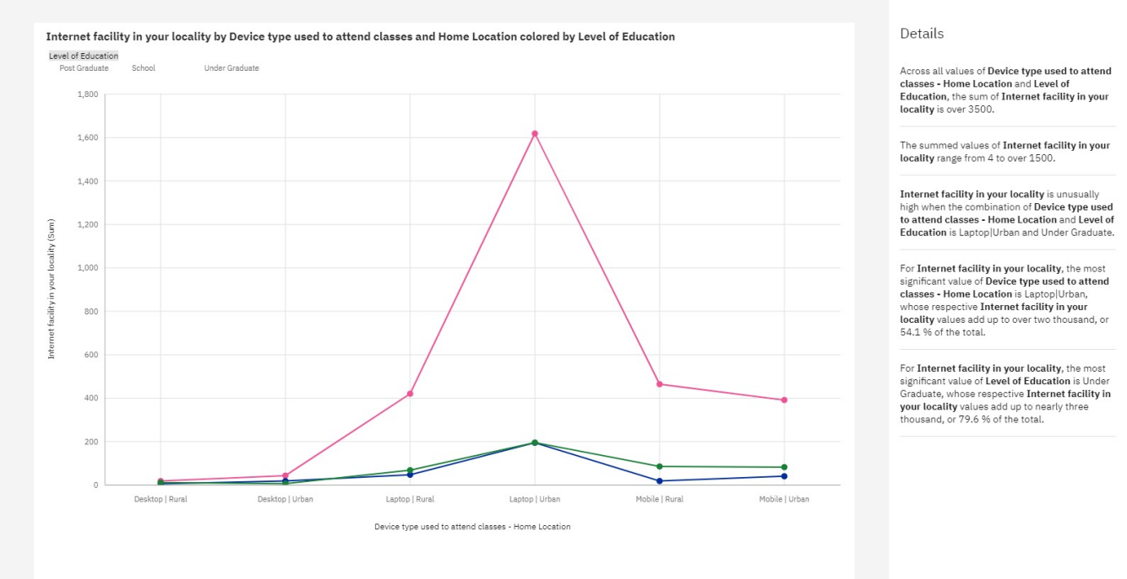
Fig 4.1 Quantitative analysis based on Internet availability

5 FLOWCHART
The flow chart given below describes the tasks to be done:

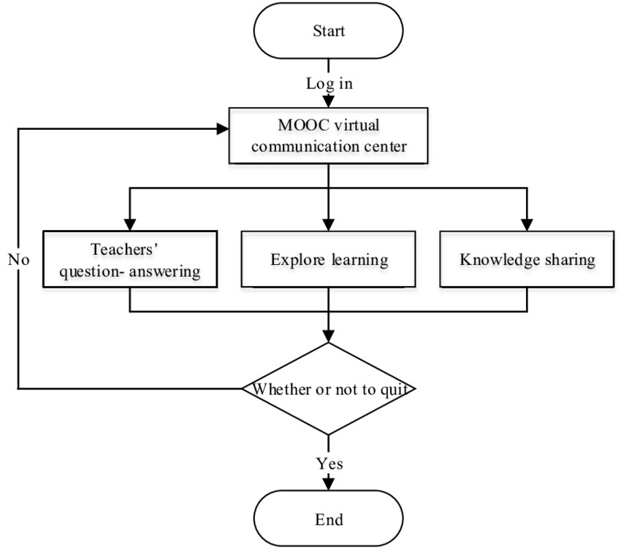

6 ADVANTAGES & DISADVANTAGES

- Cognos Active Reports are transportable. They can be e-mailed
- Cognos Active Reports are great for offline consumption. They can be executed while away from the office.
- Cognos Active Reports work with iPads
- Cognos Active Reports can be flashy.

7 APPLICATIONS

This can be used by farmers and business decision makers to analyse and investigate data sets and summarize their main characteristics. Also can be used to see what data can reveal beyond the formal modelling or hypothesis testing task and provides a better understanding of data set variables and the relationships between them. It can also help determine if the statistical techniques you are considering for data analysis are appropriate.

8 CONCLUSION

The proposed work deals with data visualization using IBM Cognos Analytics platform. Crop yield estimation dataset was used to perform the task. Creating a dashboard and by generating individual visualizations, we will get most of the insights of Crop production in India. The dashboard created using this platform acts as a single point where each and every change in the data could be analysed.

9 FUTURE SCOPE
Future scope of virtual classrooms include hyper-personalized learning experiences, AI-powered virtual tutors, seamless integration of AR and VR, enhanced collaboration tools, and innovative methods of skills

10 BIBILOGRAPHY
References:

- "A Systematic Review of Online Learning During the COVID-19 Pandemic" by Li, J., & Lalani, S. (2021). Computers & Education, 168, 104280.
- "The Impact of Online Learning on Student Outcomes: A Meta-Analysis of the Literature" by Margaryan, A., Chatti, M. A., Tiefenthaler, D., & Specht, M. (2015). Computers & Education, 80, 94–108.
- "Predictors of Student Satisfaction with Online Learning: A Meta-Analysis" by Richardson, J. C., & Cheung, W. (2019). Computers & Education, 136, 103264.
- "The Role of Social Presence in Online Learning: A Meta-Analysis" by Tu, C.-H., & McIsaac, M. S. (2002). The Internet and Higher Education, 5(2), 131–150.
- "The Effectiveness of Online Learning: A Meta-Analysis of the Empirical Literature" by Zhang, J., & Nunamaker, J. F. (2015). Journal of Management Information Systems, 31(1), 27–59.

APPENDIX

- Source Code

index.html
<!DOCTYPE html>
<html lang="en">

<head>
<meta charset="utf-8">
<meta content="width=device-width, initial-scale=1.0" name="viewport">

<title>Mentor Bootstrap Template - Index</title>
<meta content="" name="description">
<meta content="" name="keywords">

<!-- Favicons -->

<link href="{{ url_for('static', filename='/img/favicon.png') }}">
<link href="{{ url_for('static', filename='/img/apple-touch-icon.png') }}">

<!-- Google Fonts -->
<link href="https://fonts.googleapis.com/css?family=Open+Sans:300,300i,400,400i,600,600i,700,700i|Raleway:300,300i,400,400i,500,500i,600,600i,700,700i|Poppins:300,300i,400,400i,500,500i,600,600i,700,700i" rel="stylesheet">

<!-- Vendor CSS Files -->
<link href="{{ url_for('static', filename='vendor/animate.css/animate.min.css') }}" rel="stylesheet">
<link href="{{ url_for('static', filename='vendor/aos/aos.css') }}" rel="stylesheet">
<link href="{{ url_for('static', filename='vendor/bootstrap/css/bootstrap.min.css') }}" rel="stylesheet">
<link href="{{ url_for('static', filename='vendor/bootstrap-icons/bootstrap-icons.css') }}" rel="stylesheet">
<link href="{{ url_for('static', filename='vendor/boxicons/css/boxicons.min.css') }}" rel="stylesheet">
<link href="{{ url_for('static', filename='vendor/remixicon/remixicon.css') }}" rel="stylesheet">
<link href="{{ url_for('static', filename='vendor/swiper/swiper-bundle.min.css') }}" rel="stylesheet">

<!-- Template Main CSS File -->

<link href="{{ url_for('static', filename='css/style.css') }}" rel="stylesheet">
<!-- =======================================================
* Template Name: Mentor
* Updated: Jul 27 2023 with Bootstrap v5.3.1
* Template URL: https://bootstrapmade.com/mentor-free-education-bootstrap-theme/
* Author: BootstrapMade.com
* License: https://bootstrapmade.com/license/
======================================================== -->
</head>

<body>

<!-- ======= Header ======= -->
<header id="header" class="fixed-top">
<div class="container d-flex align-items-center">

<h1 class="logo me-auto"><a href="{{ url_for('home') }}">The Online Education System using IBM Cognos</a></h1>
<!-- Uncomment below if you prefer to use an image logo -->
<!-- <a href="index.html" class="logo me-auto"><img src="assets/img/logo.png" alt="" class="img-fluid"></a>-->

<nav id="navbar" class="navbar order-last order-lg-0">
<ul>
<li><a class="active" href="{{ url_for('home') }}">Home</a></li>
<li>
<a href="https://us1.ca.analytics.ibm.com/bi/?pathRef=.my_folders%2Feducation_report&amp;closeWindowOnLastView=true&amp;ui_appbar=false&amp;ui_navbar=false&amp;shareMode=embedded&amp;action=run&amp;format=HTML&amp;prompt=false" width="1100" height="1000" frameborder="0" gesture="media" allow="encrypted-media" allowfullscreen="">Report</a></li>
<li><a href="https://us1.ca.analytics.ibm.com/bi/?perspective=story&amp;pathRef=.my_folders%2Fonline_education_story&amp;closeWindowOnLastView=true&amp;ui_appbar=false&amp;ui_navbar=false&amp;shareMode=embedded&amp;action=view&amp;sceneId=model00000188a434770d_00000002&amp;sceneTime=0" width="1100" height="1000" frameborder="0" gesture="media" allow="encrypted-media" allowfullscreen="">Story</a></li>
<li><a href="https://us1.ca.analytics.ibm.com/bi/?perspective=story&amp;pathRef=.my_folders%2Fonline_education_story&amp;closeWindowOnLastView=true&amp;ui_appbar=false&amp;ui_navbar=false&amp;shareMode=embedded&amp;action=view&amp;sceneId=model00000188a434770d_00000002&amp;sceneTime=0" width="1100" height="1000" frameborder="0" gesture="media" allow="encrypted-media" allowfullscreen="">Visualization</a></li>

<i class="bi bi-list mobile-nav-toggle"></i>
</nav><!-- .navbar -->

</div>
</header><!-- End Header -->

<!-- ======= Hero Section ======= -->
<section id="hero" class="d-flex justify-content-center align-items-center">
<div class="container position-relative" data-aos="zoom-in" data-aos-delay="100">
<h1>Learning Today,<br>Leading Tomorrow</h1>
<h2>We are team of talented designers making websites with Bootstrap</h2>
<a href="{{ url_for('course') }}" class="btn-get-started">Get Started</a>
</div>
</section><!-- End Hero -->

app.py

from flask import Flask, request, render_template

app = Flask(__name__)

@app.route("/")
def home():
return render_template("index.html")

@app.route("/about")
def about():
return render_template("about.html")
@app.route("/course")
def course():
return render_template("courses.html")
@app.route("/trainers")
def trainers():
return render_template("trainers.html")

if __name__ == "__main__":
app.run(debug=True)

